**DISADVANTAGES OF CLOUD COMPUTING OVER ON-PREMISE**

**Dependency on Internet Connectivity:** Cloud computing heavily relies on a stable internet connection. In cases of network outages or unreliable connectivity, users may experience disruptions in accessing cloud services and data.

**Data Security Concerns:** Storing sensitive data in the cloud raises security concerns. Although cloud providers implement robust security measures, there is always a risk of unauthorized access or data breaches. Organizations must carefully evaluate security controls and protocols implemented by cloud service providers.

**Limited Control and Customization:** Cloud solutions often provide limited control over underlying infrastructure and software. Organizations may face constraints in customizing the environment to meet specific requirements, which can be a challenge for businesses with unique needs or compliance obligations.

**Potential Vendor Lock-In:** Moving data and applications to a specific cloud provider may result in vendor lock-in. Transferring resources to another provider or back to an on-premise environment can be complex and time-consuming, potentially causing disruptions and additional costs.

**Cost Considerations:** While cloud computing can offer cost savings, it is not always the most cost-effective option for all workloads or scenarios. Organizations need to carefully analyze their usage patterns, long-term costs, and potential hidden expenses, such as data transfer or storage retrieval fees.

**Data Transfer Speed and Latency:** Uploading or downloading large amounts of data to and from the cloud can be time-consuming and subject to network bandwidth limitations. Latency can impact real-time applications or scenarios where immediate data access is critical.

**CLOUD DEPLOYEMENT MODEL**

Cloud deployment models also define relationships between the cloud infrastructure and your users (what users are allowed to change or implement). It defines your cloud architecture, scalability of your computing resources, what you can change, services provided to you, and how much of the build you own.

The “cloud, cloud computing, or cloud service, refers to the computing resources that is been managed by someone else. They provide scalability, reliability, resiliency, and relieve ourselves of some of that work and to be more cost-effective and reduce upfront costs.

If you use a public cloud but also have your own physical servers or a datacenter, and you wish to use both as one system. This is a deployment model known as “hybrid cloud.” Even if you don’t use the public cloud at all, you could still have “a cloud.” Your own data center could host a “private cloud” if you provide services that abstract away the concerns of the hardware and physical infrastructure.

There is no absolute best cloud model, but the best fit cloud solution for your use case, your workflow, and your business needs can be determined by understanding the pros and cons of each model.

1. **Public Cloud**

A public cloud deployment is best identified by the characteristic that you don’t own any hardware or infrastructure, all your resources are provided to you by a cloud service provider. “Public” in this model means that such a cloud is available for the general public, and resources are shared between all users, also known as “[multitenancy](https://www.gartner.com/en/information-technology/glossary/multitenancy" \l ":~:text=Multitenancy%20is%20a%20reference%20to,logically%20isolated%2C%20but%20physically%20integrated." \t "_blank).”

The biggest advantage of the cloud services are elastic scalability, resource efficiency, and reducing upfront capital investment. To build a platform that intermittently experiences high load. Without a cloud provider, you would have to provide enough resources to handle the load at peak and have resources enough to handle that load, leaving you with servers that are underutilized most of the time. In that case, you’ve optimized for performance but this is less cost-effective. You might only provision enough servers to handle the average load, but then your application would either fail under high load or simply perform poorly at peak. Your workloads won’t have the resources they need, but you have cost savings.

Additionally, you’re billed only for the resources you use, and you can provision resources on an on-demand basis to scale up for bursts of activity with cloud bursting and scaled down in off-peak times with auto-scaling rules. Cloud providers also offer many higher-order services besides simple virtual machines, networking, and storage. Finally, in many cases your systems can auto-scale (up or down) to meet the load your system is under.

[Amazon Web Services](https://aws.amazon.com/) (AWS), [Microsoft Azure](https://azure.microsoft.com/), [IBM Cloud](https://www.ibm.com/cloud), and [Google Cloud](https://cloud.google.com/) are all popular public cloud providers.

Advantages

* Built to support workloads of virtually any scale, large or small
* Ease of provisioning without upfront cost
* Massive catalog of services from bare metal to business services
* Cost-effective with competitive pricing between public cloud providers

Disadvantages

* Shared tenancy (risk of sensitive data exposure to other tenants, [ChaosDB](https://www.wiz.io/blog/chaosdb-how-we-hacked-thousands-of-azure-customers-databases" \t "_blank))
* Data residency/privacy regulations might not be satisfied in the public cloud
* 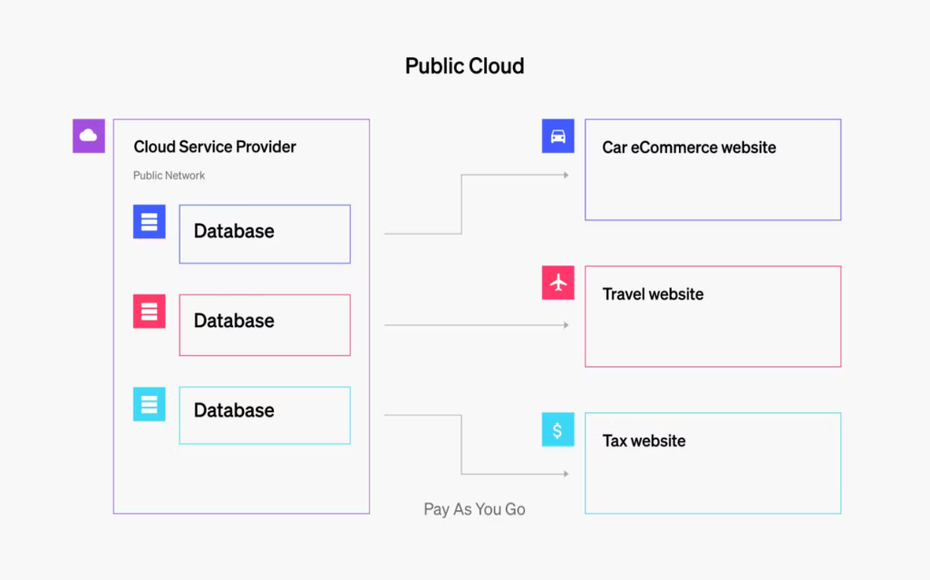Pay for everything you use, almost nothing is free including datacenter cost

1. **Private Cloud**

The key difference between a data center and a private cloud is how the resources are managed and provisioned. Having a private cloud means that consumers of your cloud are able to provision resources much like they would in the public cloud. Individual delivery do not purchase the hardware on which their system runs and they expect a resilience in the cloud such that hardware failures should not disrupt their uptime. With an abstraction layer on top of your physical servers, you gain a flexibility similar to a public cloud. As you add new servers to your data center, with a private cloud you add them to your cluster of servers adding to your scalability as a private cloud and keep those details obscured from your consumers, application delivery teams and their ops teams.

Surprisingly, you can also get a private cloud from a public cloud provider. A cloud provider will isolate resources from its cloud and make them available only to you, you won’t share tenancy with other companies in that private cloud, but you no longer have to host the physical hardware and infrastructure or maintain it. Regardless of how your private cloud is hosted the key takeaway is that resources are dedicated to a single organization.

Some well-known private cloud providers are: [Red Hat OpenStack](https://www.redhat.com/en/technologies/linux-platforms/openstack-platform), [Rackspace](https://www.rackspace.com/), IBM Bluemix Private Cloud, [Microsoft Azure Stack](https://azure.microsoft.com/en-us/products/azure-stack/), and VMware Private Cloud.

Advantages

* Less risk of exposing sensitive data as tenancy is limited to your organization
* Greater control over data storage residency and data privacy concerns
* Much more restrictive access, increasing security
* Great alternative to on-premise computing

Disadvantages

* Considerably more restrictive catalog of service offerings when limited to the private cloud
* Pricing is considerably higher as the initial outlay for the cloud service provider and the consumer are both higher

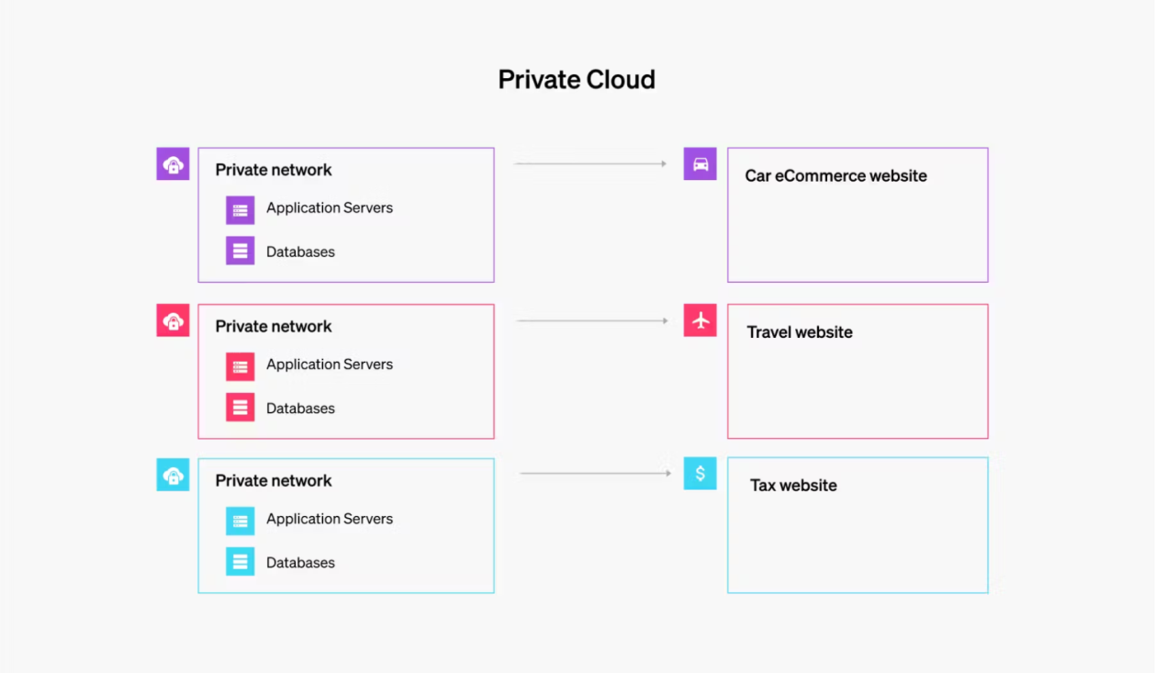

1. **Hybrid Cloud**

[Hybrid cloud model](https://cloud.google.com/learn/what-is-hybrid-cloud) is the combination of a public and private cloud. It’s the second most popular model since many companies have made considerable investments in hardware of their own and need to use it as they are in the process of cloud migration.

Creating a hybrid cloud means that a company is using the public cloud but also owns on-premises systems, and there is a connection between the two. They work as one system. This model allows for a smooth transition into the public cloud over a longer period of time.

Due to security requirements or data protection, some companies can’t operate only in the public cloud, so they may choose the hybrid cloud to combine the requirements with the benefits of a public cloud. They run mission-critical applications with sensitive data on-premises while also maintaining a public [cloud deployment model](https://launchdarkly.com/solutions/digital-transformation/). Bandwidth between the two clouds is of critical importance if the two must communicate in real-time.

Advantages

* Enable migration from on-premise to scalable cloud solutions without losing systems that work today
* Reduce the pain and cost in cloud migration while you run out the cost of your datacenter
* Get access to cloud services from your datacenter
* Keep your sensitive data on premise and greater control over privacy concerns

Disadvantages

* Infrastructure management is complex and challenging
* Migrating between on-premises and cloud services is not always a one-to-one mapping
* Scalability of on-premise systems is still challenging and can cap the scalability of your system
* 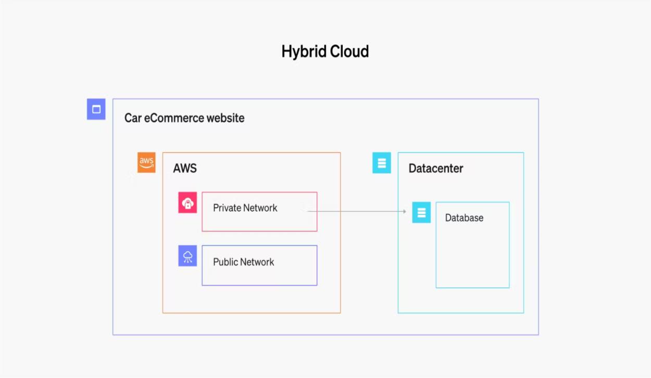Outages may be harder to diagnose and debug as the cloud architecture is more complex

1. **Multi Cloud**

In the [multi-cloud model](https://www.vmware.com/topics/glossary/content/multi-cloud.html), we use more than one cloud provider at a time. It’s similar to the hybrid [cloud deployment model](https://docs.launchdarkly.com/guides/infrastructure/infrastructure-migration), where you use both the public and private cloud.

In multi-cloud, however, instead of combining private with public, you’d use more than one public cloud. The motivations for a multi-cloud deployment are for redundancy or to optimize cost for preferred technology choices. For instance, consider running Microsoft SQL Server in the Azure public cloud may be considerably more cost effective and easier than running Microsoft SQL Server on compute instances in another public cloud provider.

Public cloud providers have invested considerably in increasing the reliability and resiliency of their services, but no system is immune to defects or outages. Given the resiliency and reliability of a single public cloud provider, multi-cloud deployment could provide even higher availability for your system as it would have extra redundancy. However, the most common reason for deploying multi-cloud is **when you need a specific service from one public cloud provider and another service from another public cloud provider.**

Advantages

* Reduce vendor stickiness and lock-in
* Potential increase in redundancy depending on your cloud architecture
* Reduced limits in the catalog of cloud solutions available to you

Disadvantages

* Moving data in the cloud costs you as you consume cloud service providers bandwidth ([AWS Data Transfer costs](https://aws.amazon.com/blogs/architecture/overview-of-data-transfer-costs-for-common-architectures/))
* Requires cultivation of multiple deployment/pipeline strategies for delivering to multiple cloud service providers
* Considerably more complex cloud architecture leads to difficult to observe and troubleshoot systems
* Very challenging to optimize and find cost savings because of the distribution of costs and resources

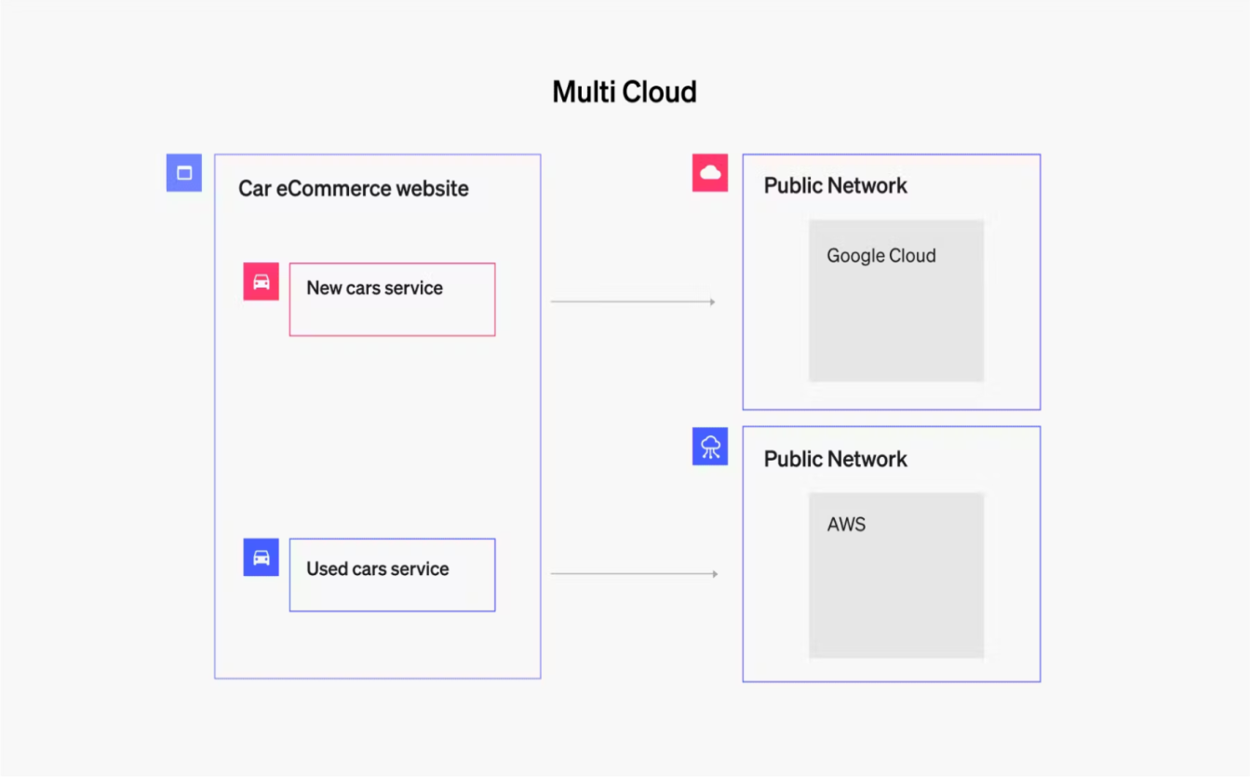

1. **Community Cloud**

[Community cloud](https://cloud.google.com/blog/products/identity-security/software-defined-community-cloud-new-way-government-cloud) is dedicated to a few organizations from the same community. Thus, it’s not a public cloud because it’s not open for everyone, but it’s also not a private cloud because there is more than one user/organization using it.

An example of a community cloud could be a cloud that a few different banks use. The biggest advantage of a community cloud is the fact that it can be tailored to requirements for a specific community. In fact, you might even think of this as a gated community, it’s not private, but within that community are generally a group of similarly interested or invested consumers.

Advantages

* Much of the control of a private cloud without all the burden of owning the cloud infrastructure yourself
* Optimize cloud architecture and resourcing for the cloud computing workloads of the community

Disadvantages

* Still has multi-tenant risks present in the public cloud, but with a smaller blast radius

**